Tabitha Geiger

11/04/2023

Week 6 – Sorting

• **Show me that you can sort data**For example, we could:

• Alternatively, we could get some practice with a GUI and sort **10 graphical rectangles**:

1. Create a collection of 10 int values,
2. Create a GUI to display the collection of int values as rectangles,
3. Include a button to start the sort process,
4. Highlight the candidate value(s) both before and after moving the value(s) at each step of the sorting process,
5. Pause after highlighting the candidate value(s)(before and after moving, possibly with different colors),  
   (perhaps for 100-250ms based on a speed button or slider?)
6. Make it obvious when it has finished sorting the data set.  
   (perhaps things flash, a border appears around the data set, or something pops up saying it completed)

• What kinds of tests would be useful for this?  How could we test some of it to verify that it was working properly?

• Implement some of those tests in PyTest!

• Take a screenshot of each of the numbered items being demonstrated above;  
Highlight, underline, or otherwise make obvious the item you are highlighting;  
Explain in a sentence or two how your code accomplished that item (you can show a snip of code if it makes it easier to explain).

1. 

Using a range of 10 integer values from 1 – 100, I assigned them to the variable self.data.

1. 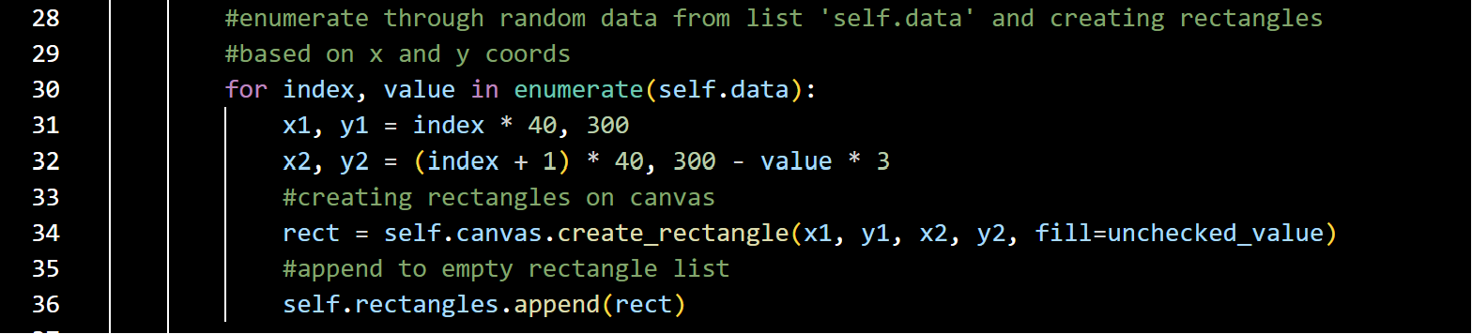

X1,y1 establishes that each rectangle will start at the same place

X2,y2 establishes how tall each rectangle is based on their value. So rectangles with a higher value are also taller.

Then once the rectangles are created with create_rectangle(), they are appended to the self.rectangle[] created earlier in the code.

1. 

The button! No lambda needed as self.sort() requires no params.

1. & 5.

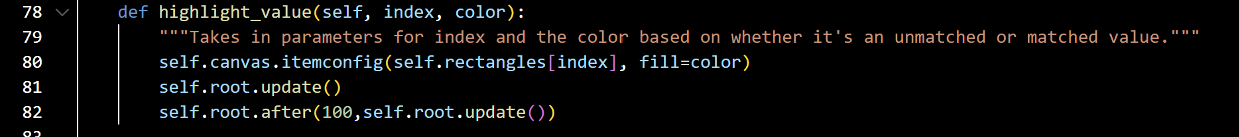

I created a function that holds two additional parameters (index for the rectangle’s ‘position’ and color).

For example, while j has not been checked in the for loop, it will have the color of ‘unchecked_value’ which in my case is purple.

I also used pause and self.root.update to for the ‘speed’ at which it moves through the rectangles.

6.

From tkinter import messagebox. I made my own function to show the message (with a parameter of what the message will be added to it. This will alert anyone who needs to know when the sorting is finished.